# SQL

1Harjutus

ATTACH DATABASE 'pood_tkandmaa.db' as 'epood';

.tables

Select * from tkandmaa

CREATE TABLE tkandmaa(

id INTEGER PRIMARY KEY AUTOINCREMENT,

first_name VARCHAR(255) NOT NULL,

last_name VARCHAR(255) NOT NULL,

email VARCHAR(255) NOT NULL,

car_make VARCHAR(255) NOT NULL,

car_model VARCHAR(255) NOT NULL,

car_year INTEGER NOT NULL,

car_price REAL NOT NULL);

INSERT INTO tkandmaa(first_name,last_name,email,car_make,car_model,car_year,car_price)

VALUES( „Mart“, „parm“, „[mart.parm@gmail.com](mailto:mart.parm@gmail.com)“, „toyota“, „corolla“, 2024, 6900.00);

VALUES( „Karlos“, „Kolk“, „[karlos.kolk@gmail.com](mailto:karlos.kolk@gmail.com)“, „honda“, „civic“, 1978, 33.00),

VALUES( „Tiit“, „koer“, „[tiit.koer @gmail.com](mailto:karlos.kolk@gmail.com)“, „bmw“, „bambus“, 2004, 1200.00);

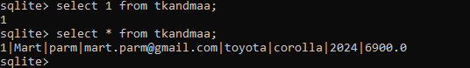

SEE TÖÖTAB!!!

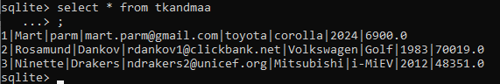

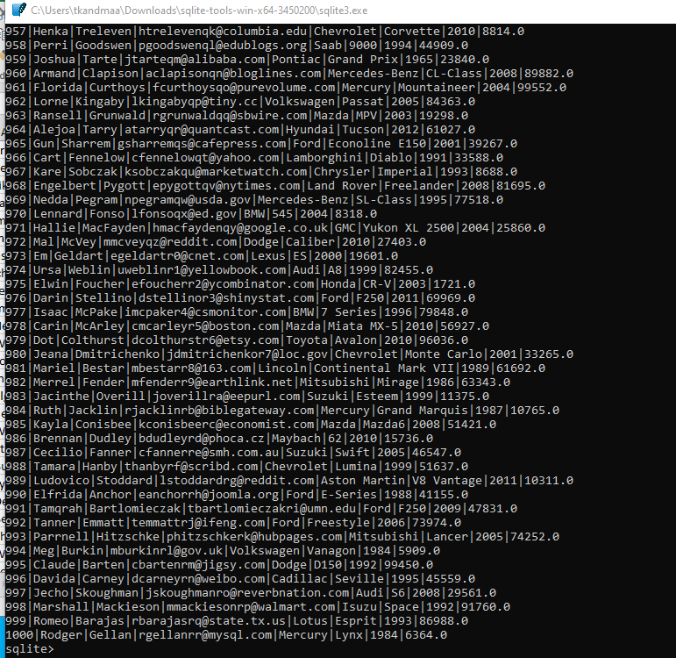

# Üelesanaen 2

UPDATE tkandmaa SET car_make = 'Citroën' WHERE car_make = 'Cadillac';

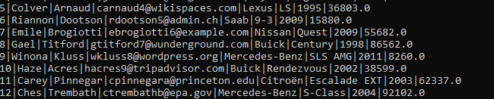

UPDATE tkandmaa SET car_make = 'Zaporožets' WHERE car_make = 'toyota'

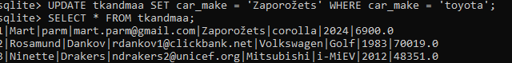

DELETE FROM tkandmaa WHERE id IN (5, 10, 15);

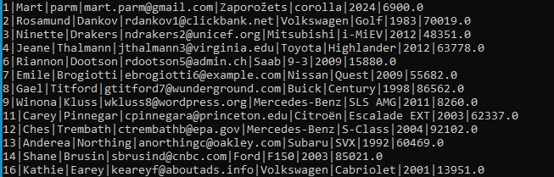

SELECT id, last_name AS perenimi, car_make AS automark, car_year AS aasta FROM tkandmaa ORDER BY id ASC;

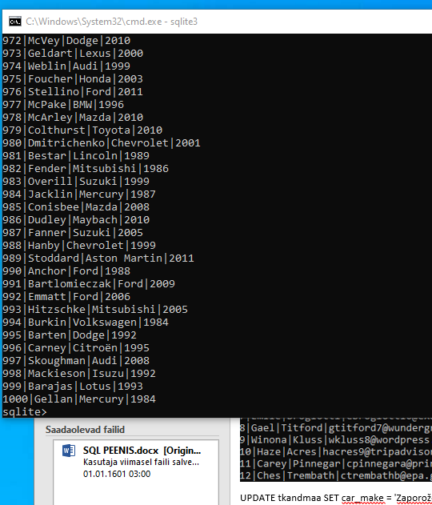

SELECT first_name, last_name, car_make, car_model, car_year

FROM tkandmaa

WHERE last_name LIKE 'T%'

ORDER BY car_year DESC

LIMIT 10;

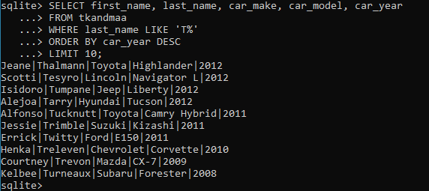

SELECT * FROM tkandmaa WHERE car_make IN ('Toyota', 'Audi') AND car_price > 3000;

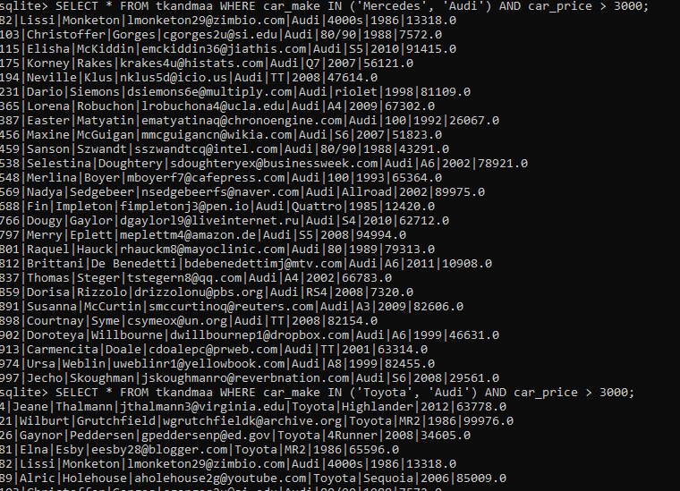

# Harjutus 3

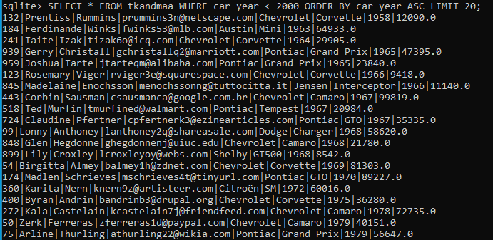

SELECT AVG(car_year) AS keskmine_aasta, MAX(car_price) AS kõige_kallim_hind FROM tkandmaa;

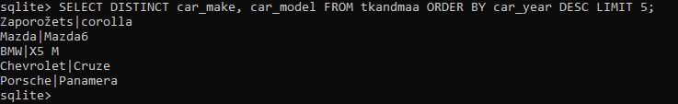

DELETE FROM tkandmaa WHERE id = **20 ( vali number ja KUSTUAB**

DELETE FROM autod WHERE car_year < 2000 AND car_make = 'Mercedes';

SELECT last_name, car_model ,car_make, car_year, car_price

FROM tkandmaa

ORDER BY last_name ASC

LIMIT 5;

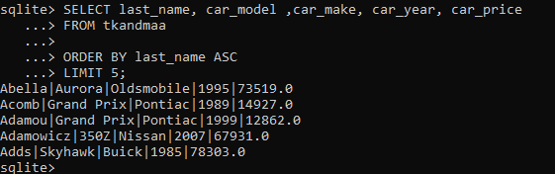

.mode csv

.headers on

.output sqlliteautod.csv

SELECT * FROM tkandmaa;

Lisan csv fiali kuhugi ara muretse mario :D: D:D :D D:D:D

Pythoni osa

Kustutamine töötab. Testimiseks kustutasin 11. ära

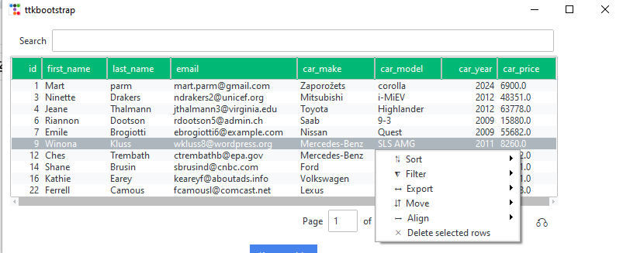

Tänu selle style=dark asjale näeb see väga imelik välja.

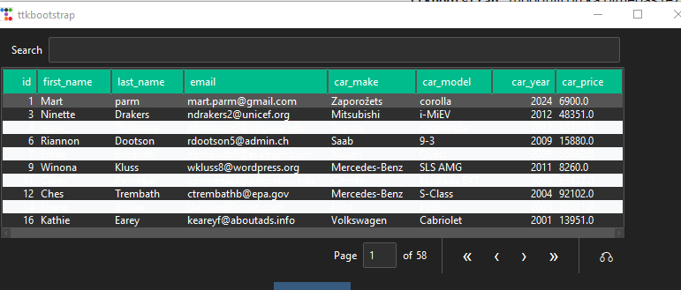

import ttkbootstrap as ttk

import sqlite3

from ttkbootstrap.tableview import Tableview

from ttkbootstrap.constants import *

from ttkbootstrap import Style

def delete_row():

selected_row = dv.get_selected_row()

if selected_row:

confirmation = messagebox.askyesno("Kustuta rida", "Kas olete kindel, et soovite selle rea kustutada?")

if confirmation:

index = dv.get_selected_index()

dv.delete_row(index)

delete_from_database(selected_row[0]) # Kustutame andmebaasist vastava rea

def delete_from_database(row_id):

connection = sqlite3.connect('epood_tkandmaa.db')

cursor = connection.cursor()

cursor.execute('DELETE FROM tkandmaa WHERE id=?', (row_id,))

connection.commit()

connection.close()

def show_percentage():

connection = sqlite3.connect('epood_tkandmaa.db')

cursor = connection.cursor()

cursor.execute('SELECT COUNT(*) FROM tkandmaa')

total_cars = cursor.fetchone()[0]

cursor.execute('SELECT COUNT(*) FROM tkandmaa WHERE car_make=?', ('Mercedes',))

mercedes_count = cursor.fetchone()[0]

cursor.execute('SELECT COUNT(*) FROM tkandmaa WHERE car_make=?', ('Audi',))

audi_count = cursor.fetchone()[0]

mercedes_percentage = (mercedes_count / total_cars) * 100

audi_percentage = (audi_count / total_cars) * 100

percentage_text.set("Mercedes: {:.2f}%\nAudi: {:.2f}%".format(mercedes_percentage, audi_percentage))

cursor.close()

connection.close()

my_w = ttk.Window()

my_w.geometry("800x300") # width and height

colors = my_w.style.colors

style = Style(theme='darkly')

l1 = [

{"text": "id", "stretch": False},

{"text":"first_name","stretch":True},

{"text":"last_name","stretch":True},

{"text":"email","stretch":True},

{"text":"car_make","stretch":True},

{"text":"car_model","stretch":True},

{"text":"car_year","stretch":True},

{"text":"car_price","stretch":True}

] # Columns with Names and style

#database query

connection = sqlite3.connect('epood_tkandmaa.db')

cursor = connection.cursor()

cursor.execute('SELECT * FROM tkandmaa')

r_set = cursor.fetchall()

# Näitame tulemused

#for row in rows:

#print(rows)

# Data rows as list

#r_set = [(1, "Alex", 'Four',90,'Female'), (2, "Ron", "Five",80,'Male'),

#(3, "Geek", 'Four',70,'Male'),(4,'King','Five',78,'Female'),

#(5,'Queen','Four',60,'Female'),(6,'Jack','Five',70,'Female')]

marks=[r[3] for r in r_set] # List of all marks column

dv = ttk.tableview.Tableview(

master=my_w,

paginated=True,

coldata=l1,

rowdata=r_set,

searchable=True,

bootstyle=SUCCESS,

pagesize=10,

height=10,

stripecolor=(colors.light, None),

)

dv.grid(row=0, column=0, padx=10, pady=5)

dv.autofit_columns() # Fit in current view

#dv.insert_row("end", values=['-', "---", "All", sum(marks), "All"])

delete_button = ttk.Button(my_w, text="Kustuta rida", command=delete_row)

delete_button.grid(row=1, column=0, padx=10, pady=5)

dv.load_table_data() # Load all data rows

percentage_text = tk.StringVar()

percentage_label = tk.Label(my_w, textvariable=percentage_text, font=('Arial', 12), justify='left')

percentage_label.grid(row=2, column=0, padx=10, pady=5)

show_percentage() # Kuvame protsendid alguses

my_w.mainloop()

cursor.close()

connection.close()